Experiment1.2

Student Name: Himanshu UID: 20BCS7944
Branch: CSE Section: 905/A
Semester: 6 Date of Performance: 16/02/2023
Subject Name: IOT Lab Subject Code: 20CSP-358

1) Aim:

Identification of different sensors used in IoT Applications.

2) Objective:

To study hardware or sensors related to IoT.

To understand and identify different sensors use in IoT.
3) Sensors:

In the context of the Internet of Things (IoT), sensors play a crucial role in collecting data and providing insights into various physical phenomena. IoT sensors are devices that detect and measure physical parameters such as temperature, humidity, pressure, light, sound, motion, and more. These sensors are typically connected to the internet and transmit data wirelessly to a central system, where it can be analyzed and used for a variety of applications.

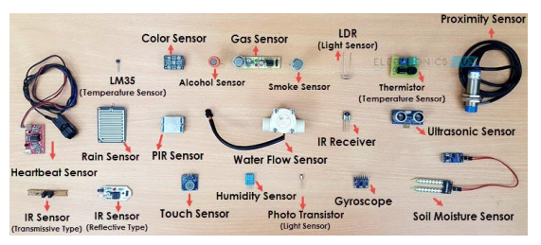

1) Temperature sensor:
A device, used to measure amount of heat energy that allows to detect a physical change in temperature from a particular source and converts the data for a device or user, is known as a Temperature Sensor.



2) Proximity sensor:
A device that detects the presence or absence of a nearby object, or properties of that object, and converts it into signal which can be easily read by user or a simple electronic instrument without getting in contact with them.



3) Pressure sensor:
A pressure sensor is a device that senses pressure and converts it into an electric signal. Here, the amount depends upon the level of pressure applied.



4) Water quality sensor:
Water quality sensors are used to detect the water quality and Ion monitoring primarily in water distribution systems.



5) Gas sensor:
Gas sensors are similar to the chemical ones, but are specifically used to monitor changes of the air quality and detect the presence of various gases



6) Humidity sensor:
Humidity is defined as the amount of water vapour in an atmosphere of air or other gases. The most commonly used terms are “Relative Humidity (RH)”.


